**Export to XLS from List View Web Part**

This component is prepared to export List Data from List View web part including view filter and user filtered columns and columns showed in the web part.

## **Features:**

* + No need to pass any list name or column name.
  + This component adds export button above list view web part dynamically.
  + It works with multiple filters including Null value filter.
  + It works with lookup columns including projected fields.
  + It works with metadata columns as well.
  + It works with multiple list view in the single page.
  + It exports list as well as library.

## **Deployment Steps**

This is a jQuery plugin so you need to include jQuery JS file and the add reference of this JS file.

You can add through Script Editor web part or content editor or direct embed this code into the page.

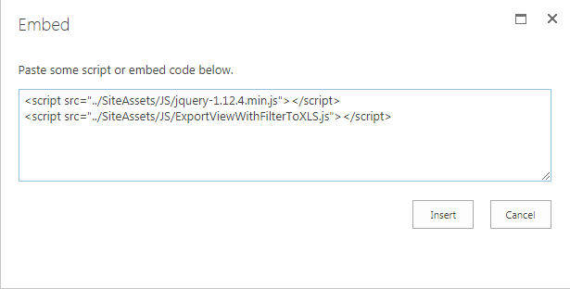

Figure 1 Using Script Editor

Once you add the script you can see the Export Button just above the list web part.

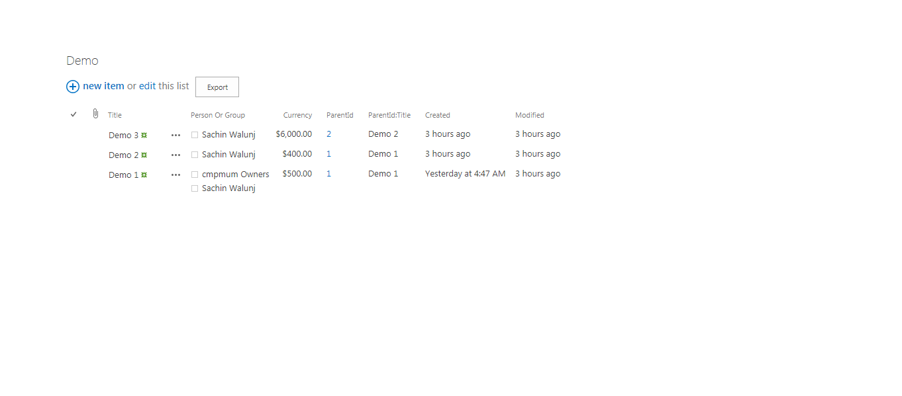

## **Deployment Steps**

1. It does not support modern pages.
2. If date column is used as lookup column, then it will not export anything.
3. If date column is used as projected column, then date format will be in ISO format.